HONORS CHEMISTRY • UNIT 4
Intermolecular Forces
Why water is a liquid but methane is a gas, why some liquids evaporate in seconds and others cling to a surface — it all comes down to the attractions BETWEEN molecules.

HOW TO USE THIS PACKET
Draw every structure yourself and write explanations in your own words. LAB CORNER boxes are things you would see or do at a lab bench. The flowchart in 4.2 is the one page to keep for the rest of the year.

What we will learn
4.1 | London dispersion forces
4.2 | Identifying the intermolecular force (dipole–dipole, hydrogen bonding)
4.3 | IMFs and the properties of liquids
4.4 | Putting it all together: boiling point, volatility, ΔHvap
★ | Extra practice & unit review

By the end of this unit I can…
• Distinguish between intramolecular and intermolecular forces and show each on a drawing.
• Explain how London dispersion forces form, why every molecule has them and why they get stronger as molecules get bigger.
• Decide whether a molecule is polar, and list every IMF it can form (LDF, dipole–dipole, hydrogen bonding).
• Draw two molecules and show the attraction between them.
• Relate IMF strength to boiling point, evaporation rate (volatility), drop shape and enthalpy of vaporization.
• Rank substances by boiling point and justify the ranking with IMFs.
• Use ΔHvap, molar mass and gas-volume relationships in calculations.
4.1 | London Dispersion Forces Intramolecular vs intermolecular • temporary dipoles • size and boiling point

BIG IDEA
There are forces inside molecules (the covalent bonds that hold atoms together) and forces between molecules (intermolecular forces, IMFs). Changes of state, like boiling, break the forces between molecules; they do not break the bonds inside them.

Key vocabulary — write each definition in your own words
Term | Definition (your words) | Example / sketch
Intramolecular force | Where is it? Give an example.
Intermolecular force (IMF) | Where is it? Is it stronger or weaker than a covalent bond?
Temporary (instantaneous) dipole | How does it form?
Induced dipole | What induces it?
London dispersion force (LDF) | Which molecules have it?
Polarizability | Why do bigger molecules have it more?

Intramolecular vs intermolecular
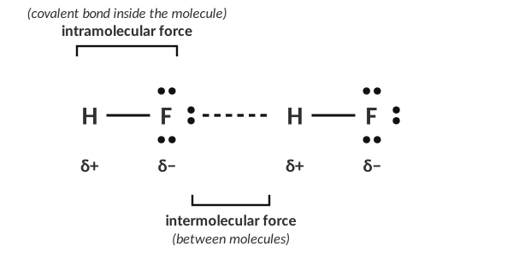
Two HF molecules: the solid line is the bond inside a molecule; the dashed line is the attraction between molecules.
1. An intramolecular force is considered a ____________________. How is it represented in a Lewis diagram?

2. Complete the Lewis structure for HF, then draw an arrow to the intramolecular force.
HF:

3. Where does an intermolecular force occur?

4. Why can two molecules be attracted to each other? What causes an IMF?

[ IMAGE GOES HERE ]
Optional: the 'which diagram shows an IMF?' choices from the homework

THINK OF IT LIKE… HOLDING HANDS VS. HOLDING A HAND-TIED ROPE
Imagine each molecule is a group of friends tied together with strong rope (the covalent bonds). The friends in different groups can only hold hands loosely (IMFs). Pulling the groups apart (boiling) only lets go of the hands; the rope stays tied.

How London dispersion forces form
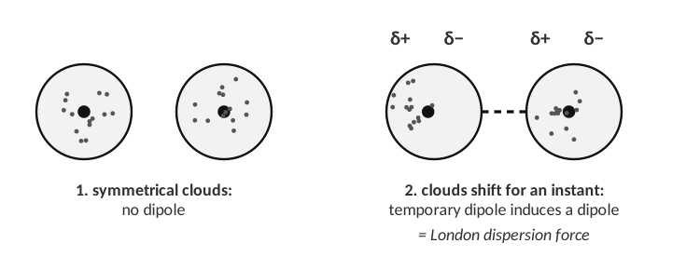
Temporary dipole → induced dipole → attraction.
CUES / KEY WORDS  Step 1  Step 2  Step 3 | DESCRIBE HOW TWO NON-POLAR MOLECULES COME TO ATTRACT EACH OTHER

5. Why are LDFs the weakest of the intermolecular forces? Your answer should discuss the dipole that is formed.

6. Explain why ALL molecules form LDF.

7. Which molecules form only LDF as their main intermolecular force?

Size matters: LDF and boiling point
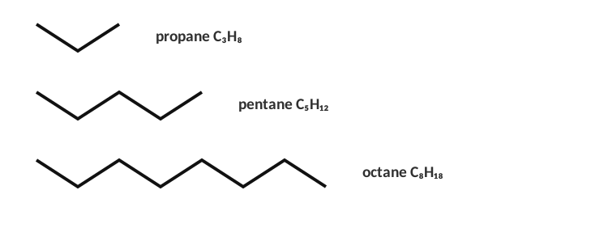
Three alkanes (skeletal structures: each corner is a carbon with enough hydrogens to make four bonds).
Formula | Number of electrons | State at room temp. | Boiling point
C₃H₈ |  | gas | −42 °C
C₅H₁₂ |  | liquid | 36 °C
C₈H₁₈ |  | liquid | 125 °C

8. What trend do you notice between the size of the molecule and the boiling point?

9. Each molecule forms only LDF. Explain what causes the trend.

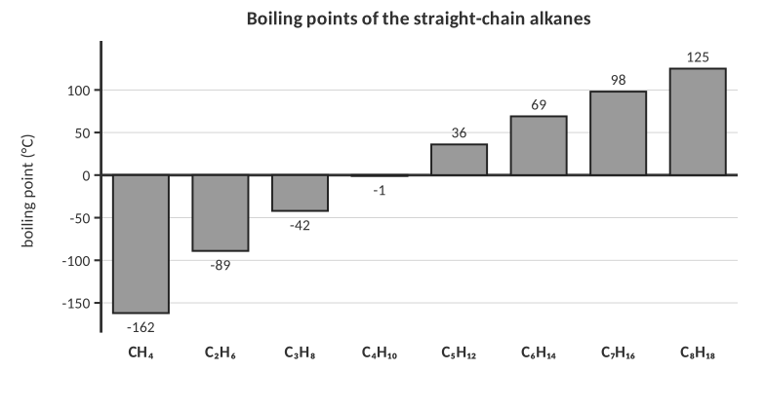
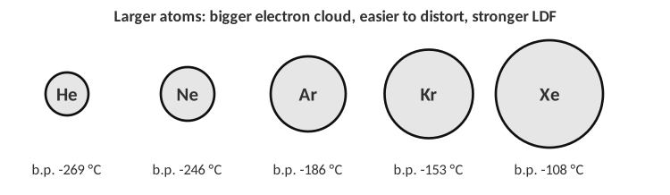
10. Predict: which has the higher boiling point, F₂ or Br₂? Which is a gas at room temperature? Explain.

11. An intramolecular force is…
A) the attraction between two molecules
B) a chemical bond within a molecule
C) only found in ionic compounds
D) the same as an LDF

12. Which has the strongest London dispersion forces?
A) CH₄ B) C₂H₆ C) C₄H₁₀ D) C₈H₁₈
13. Boiling a liquid such as water breaks…
A) the covalent bonds within molecules
B) the intermolecular forces between molecules
C) both equally
D) neither

14. Which of these only forms LDF?
A) H₂O B) CH₃Cl C) N₂ D) HF
4.2 | Identifying the Intermolecular Force Polarity → IMFs • dipole–dipole • hydrogen bonding

BIG IDEA
To find a molecule’s IMFs: draw the Lewis structure, decide the shape, and decide whether it is polar. Every molecule has LDF; polar molecules add dipole–dipole; molecules with H bonded to N, O or F add hydrogen bonding.

Key vocabulary — write each definition in your own words
Term | Definition (your words) | Example / sketch
Permanent dipole | Which molecules have one?
Dipole–dipole force | Between which molecules?
Hydrogen bonding | What are the two requirements?
Non-polar molecule | Does it have a dipole?
Main IMF | Which IMF do we call the main one?

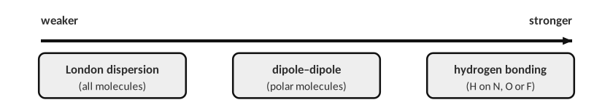
Dipole–dipole
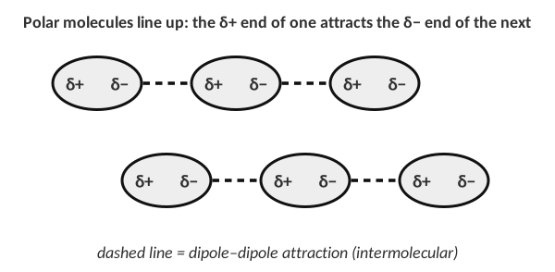
Polar molecules orient so opposite partial charges are close.
1. Why is dipole–dipole stronger than LDF for molecules of similar size?

Hydrogen bonding
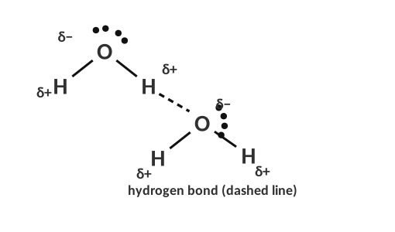
Hydrogen bonding between two water molecules.
HYDROGEN BONDING CHECKLIST
1. The molecule has a hydrogen directly bonded to N, O or F (look for N–H, O–H, F–H).
2. A neighboring molecule has a lone pair on N, O or F that the hydrogen can point to.
3. If an H is bonded to C (C–H), or the molecule has N, O or F but no N–H/O–H/F–H, there is no hydrogen bonding.

THINK OF IT LIKE… A MAGNET-STRONG HANDSHAKE
Hydrogen is tiny and, when bonded to N, O or F, its single electron is dragged away, leaving an almost bare proton. That bare end can get very close to a lone pair on a neighbor, so the attraction is much stronger than an ordinary dipole–dipole attraction.

The IMF flowchart
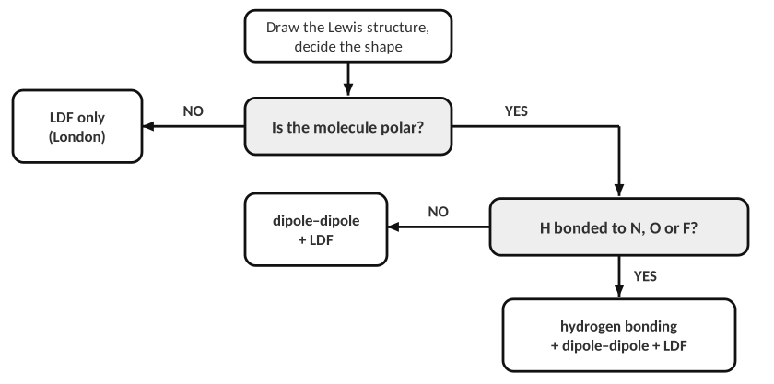
Remember: LDF is present in EVERY case.
Three molecules, three IMFs
Complete the table. Draw the Lewis structure, label the molecule polar or non-polar, give the main IMF, and say whether the molecule has a temporary or a permanent dipole.
Substance | Lewis structure | Polarity | Main IMF | Dipole type | Boiling point
Water (H₂O) |  |  |  |  | 100 °C
Methyl chloride (CH₃Cl) |  |  |  |  | −24 °C
Methane (CH₄) |  |  |  |  | −161 °C

2. Draw two CH₃Cl molecules and show the attraction between them. Label the partial charges.
Draw here:

3. Using the strength of the IMFs, explain the boiling point differences in the table.

Practice: draw, classify, and list ALL IMFs
For each molecule, draw the Lewis structure, decide polar or non-polar, and write every IMF it forms.
Molecule | Lewis structure | Polarity | All IMFs
Carbon tetrachloride, CCl₄
Carbon monoxide, CO
Carbon disulfide, CS₂
Hydrogen sulfide, H₂S
Hydrogen fluoride, HF
Oxygen gas, O₂
Diethyl ether, (CH₃CH₂)₂O
Hydrogen cyanide, HCN

4. Which molecule can form hydrogen bonds with other molecules of its own kind?
A) CH₄ B) CH₃Cl C) NH₃ D) H₂S
5. Which of these has only LDF?
A) HCl B) CCl₄ C) NH₃ D) H₂O
6. The main IMF in CH₃Cl is…
A) LDF B) dipole–dipole C) hydrogen bonding D) ionic bonding
7. Which molecule has a temporary dipole only?
A) H₂O B) HF C) CH₄ D) CH₃Cl
4.3 | IMFs and the Properties of Liquids Surface tension • evaporation • volatility • hydrogen-bond drawings

BIG IDEA
The stronger the IMFs, the harder it is for molecules to leave the liquid or slide past each other. So strong IMFs mean: higher boiling point, lower volatility (evaporates slowly), lower vapor pressure, higher surface tension and higher viscosity.

Property | What it means | Strong IMF → ?
Boiling point
Volatility / evaporation rate
Vapor pressure
Surface tension
Viscosity
ΔHvap

LAB CORNER • Three drops on a flat surface

A student places 1 drop of each substance (water, pentane and acetone) on a flat surface and draws what they see. The drawings are not labeled with the names.
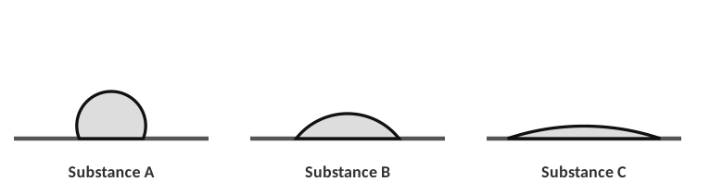
[ IMAGE GOES HERE ]
Optional: the three Lewis structures (water, pentane, acetone) from the homework

Molecule | Main IMF | Prediction: drop shape
Water
Acetone (CH₃)₂C=O
Pentane C₅H₁₂

1. What property is this student testing? How can the student figure out which drop is which substance?

2. Identify Substance A, B and C. Then explain which of the three would evaporate fastest if left out for 10 minutes.

Drawing hydrogen bonds
3. Draw two water molecules and show how they are attracted to each other (label δ+, δ− and the hydrogen bond).
Draw here:

The structure of ethanol is CH₃CH₂–O–H. Which diagram correctly shows how ethanol hydrogen-bonds with water? (Dashes = hydrogen bond.)
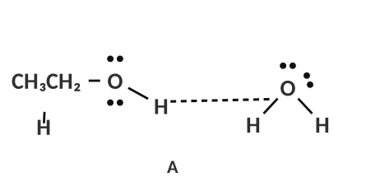 | 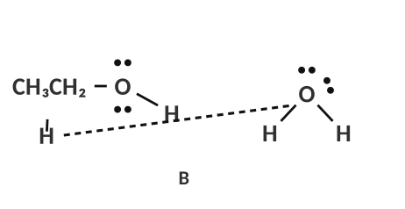 | 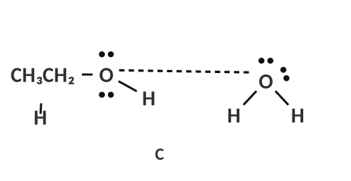
A | B | C

4. Circle the correct diagram and explain why the other two are wrong.

LAB CORNER • Evaporative cooling

Three thermometers are wrapped in cotton soaked with Liquid A, B or C (water, pentane or acetone in some order). All start at 22.0 °C and are held in the air for 3 minutes.
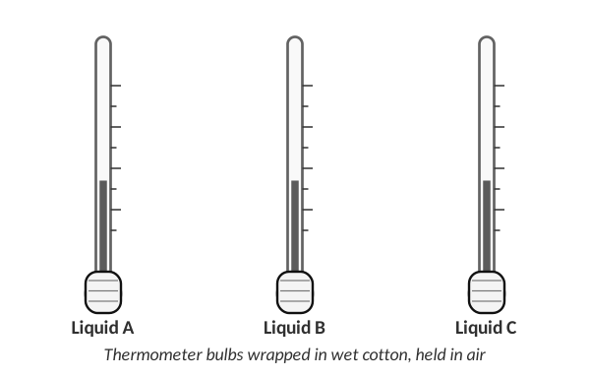
Liquid | Start (°C) | After 3 min (°C) | Change (°C) | Which liquid? (water / acetone / pentane)
A | 22.0 | 3.0
B | 22.0 | 8.5
C | 22.0 | 18.5

5. Complete the table, then identify each liquid. Explain how evaporation cools the thermometer and why the liquid with the weakest IMF cooled the most.

6. Which liquid should have the highest surface tension?
A) pentane B) acetone C) water D) hexane
7. Which substance is the most volatile?
A) C₂H₆ B) H₂O C) CH₃OH D) NaCl(aq)
4.4 | Putting It All Together Ranking • boiling point • ΔHvap • calculations

BIG IDEA
When comparing substances: (1) list every IMF each one has; (2) compare the strongest type (hydrogen bonding > dipole–dipole > LDF); (3) if the type is the same, the one with more electrons (bigger molecules) wins.

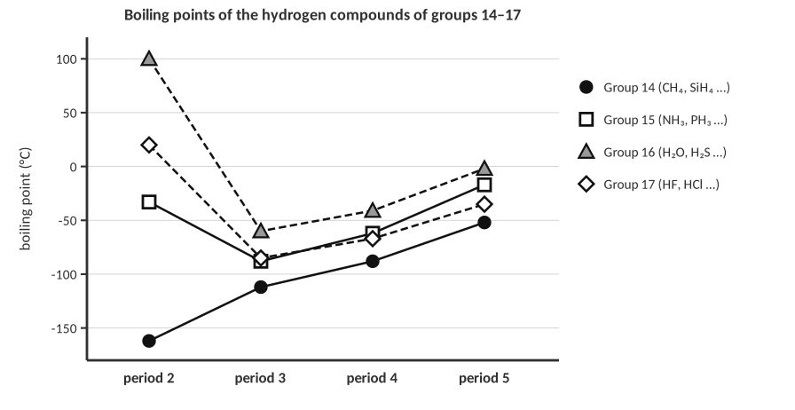
1. Look at the graph. In groups 14, 15, 16 and 17 the boiling point generally increases down a group. Why? Which three compounds break this trend and what do they have in common?

2. Place the molecules in order of increasing boiling point: HF, O₂, CO₂. _________ < _________ < _________

3. Which substance will be the most volatile (highest evaporation rate): (a) C₂H₆ (b) H₂O (c) CH₃OH? Explain.

Two non-polar molecules
 | Lewis structure | Boiling point
CH₄ |  | −162 °C
CCl₄ |  | 76 °C

4. What is the main IMF in both molecules? Why is the boiling point of CCl₄ much larger than CH₄?

5. The ΔHvap for CCl₄ is 39.4 kJ/mol. Calculate the energy (kJ) needed to vaporize 10.0 g of CCl₄ (molar mass 153.82 g/mol).
Work:

Answer (units & sig figs): __________________________________
6. Would you expect ΔHvap for CH₄ to be higher or lower than CCl₄? Explain.

Connecting to stoichiometry: propane
Propane, C₃H₈, is a colorless, odorless gas at room temperature (non-polar, only LDF; boiling point −42 °C).
7. How many liters of propane are present in 7.50 g of propane at STP? (1 mol of gas = 22.4 L at STP)
Work:

Answer (units & sig figs): __________________________________
8. Write the full balanced equation for the combustion of propane gas in oxygen.

9. The enthalpy of the reaction is ΔH = −2200.0 kJ per mole of reaction. How many kJ of energy are released when the 7.50 g of propane are burned?
Work:

Answer (units & sig figs): __________________________________
10. Which has the highest boiling point?
A) CH₄ B) C₅H₁₂ C) H₂O D) C₂H₆
11. Which has the largest ΔHvap?
A) CH₃OH B) C₂H₆ C) CH₄ D) Ne
PRACTICE
Extra Practice — Unit 4
Show your reasoning.

A. Identify the IMFs
Molecule | Polar? | All IMFs present | Hydrogen bonds with itself?
NH₃
CH₃OH
CO₂
CH₃Cl
Cl₂
HBr
C₆H₁₄
CH₃COOH

B. Rank by boiling point (lowest → highest) and justify
Set | Ranking and one-sentence reason
He, Ne, Ar, Kr
CH₄, NH₃, H₂O
HCl, HF, Cl₂
CH₃CH₂CH₃, CH₃OCH₃, CH₃CH₂OH

C. Explain
1. Water (18 g/mol) boils at 100 °C but H₂S (34 g/mol) boils at −60 °C. Explain, using IMFs.

2. Explain why ice floats on liquid water. (Hint: hydrogen bonds.)

3. Gasoline (mostly C₈H₁₈) is more volatile than motor oil (long hydrocarbons, C₂₀ and larger). Explain using IMFs.

4. A student says: “When water boils, the H–O bonds break to form hydrogen and oxygen gas.” Correct the statement.

D. Quick checks
5. Which molecule has hydrogen bonding as its main IMF?
A) CH₃F B) CH₃OCH₃ C) CH₃NH₂ D) HCl
6. Which has the highest vapor pressure at 25 °C?
A) water B) ethanol C) hexane D) glycerol
7. What is the dipole type in a pure sample of Br₂?
A) permanent only B) temporary C) none; atoms are neutral D) hydrogen bond
8. As the number of electrons in a nonpolar molecule increases, its boiling point…
A) decreases B) increases C) stays the same D) doesn’t depend
Unit 4 review
9. Describe the three types of IMF in order from weakest to strongest and give an example of each.

10. Explain the steps you take to predict the IMFs in a molecule you have never seen.

